Date: Click or tap here to enter text.

To Whom It May Concern:

This letter is to verify that Click or tap here to enter text. has been offered the following on-campus employment at SUNY Jamestown Community College

**Position:** Click or tap here to enter text.

**Brief Description of Duties**: Click or tap here to enter text.

**Start Date:** Click or tap here to enter text. **Hours Per Week:** Click or tap here to enter text.

**Employment Identification Number (EIN):** Click or tap here to enter text.

**Supervisor Name** Click or tap here to enter text.

**Supervisor’s Phone Number:** Click or tap here to enter text.

**Supervisor Signature:**

If you have any questions, please do not hesitate to contact me.

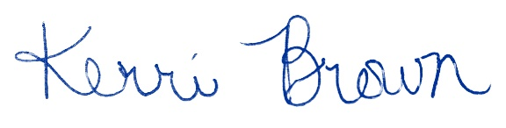

**Kerri Brown**| She, Her, Hers

Director of Global Learning, Primary Designated School Official

PH: +1 716-338-1291  
[sunyjcc.edu](https://www.sunyjcc.edu/)

Jamestown Community College  
525 Falconer Street | P.O. Box 20 | Jamestown, NY 14702-0020